Background Information

Strain Number | T005170
Strain Name | B6/JNju-Hectd4^{em1Cflox}/Gpt
Used name | Gm15800; AU042671; BC019639; EG545802; mKIAA0614; A130010L24
Common name | Hectd4
Complete time | 2019/2/20
Strain Type | Conditional Knock out Cas9
origin | Gempharmatech
Background | C57BL/6J
Algebra | F1
appearance | Black
Related geneS | Hectd4
genotype | Fl/wt
Provided genotype | Heterozygote
Targeting Strategy | 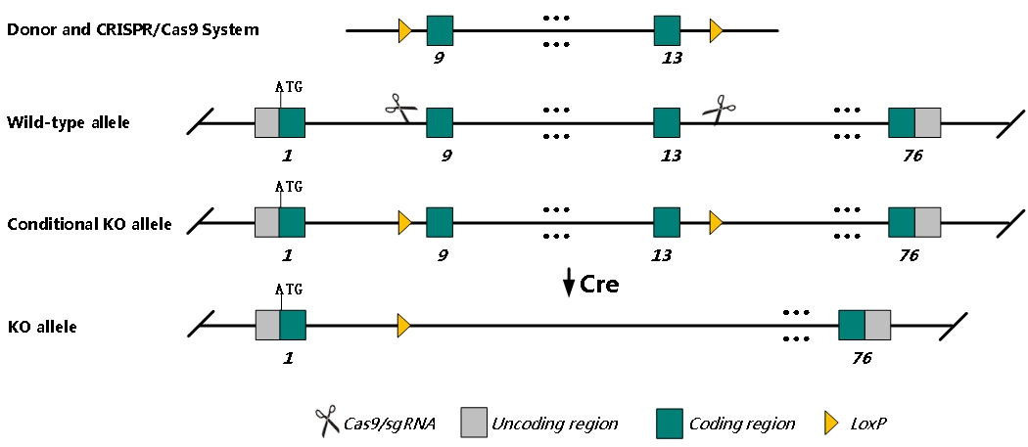
sgRNA | GACCATCCCATAGGAGACTT GGG GCCTGGCAAAGCTCTTTCAA GGG
Breeding method（♂x♀）
status | frozen
Genotyping | PCR+Sequence
Special feeding conditions | None
feed | SPF
maternal instinct | general
Strain description | /
Research areas | /
Reference

