Background Information

Strain Number | T005129
Strain Name | B6/JNju-Ube2a^{em1Cflox}/Gpt
Used name | HR6A; HHR6A; Mhr6a
Common name | Ube2a
Complete time | 2019/2/26
Strain Type | Conditional Knock out Cas9
origin | Gempharmatech
Background | C57BL/6J
Algebra | F1
appearance | Black
Related geneS | Ube2a
genotype | Fl/wt
Provided genotype | Heterozygote
Targeting Strategy | 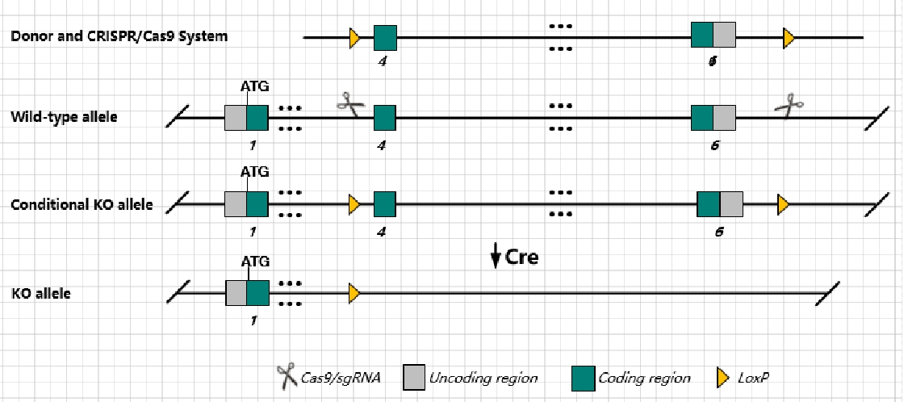
sgRNA | CTTGGCAAGTTATGGTCATC AGG AGGGTACTTAAACCTCATTG TGG
Breeding method（♂x♀）
status | frozen
Genotyping | PCR+Sequence
Special feeding conditions | None
feed | SPF
maternal instinct | general
Strain description | Homozygous mutation of this gene results in decreased body weight. Females are infertile while males show partial prenatal lethality.
Research areas | Developmental Biology
Reference

