Background Information

Strain Number | T005154
Strain Name | B6/JNju-Kdm2b^{em1Cflox}/Gpt
Used name | Cxxc2; Fbl10; PCCX2; Fbxl10; Jhdm1b
Common name | Kdm2b
Complete time | 2019/2/27
Strain Type | Conditional Knock out Cas9
origin | Gempharmatech
Background | C57BL/6J
Algebra | F0+F1
appearance | Black
Related geneS | Kdm2b
genotype | Fl/wt
Provided genotype | Heterozygote
Targeting Strategy | 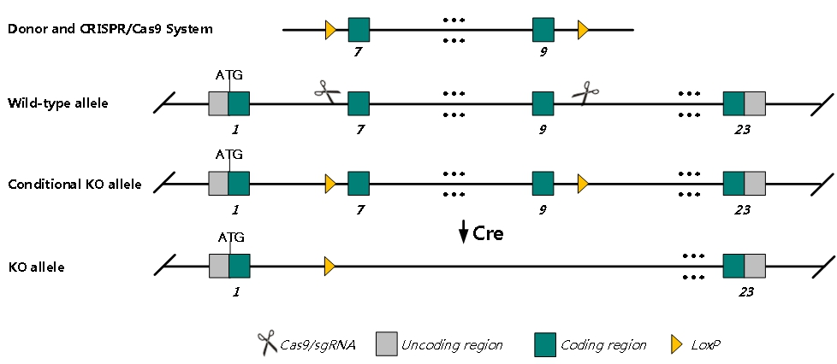
sgRNA | GGCACGGTACTGAGAGAAAT GGG TGCTGTAGTTTGCAGGGCAT AGG
Breeding method（♂x♀）
status | frozen
Genotyping | PCR+Sequence
Special feeding conditions | None
feed | SPF
maternal instinct | general
Strain description | Mice homozygous for a targeted allele that does not express the long form protein exhibit exencephaly, fetal and postnatal lethality, coloboma, curly tail, oligozoospermia, increased apoptosis, and increased neuronal precursor proliferation.
Research areas | Developmental Biology
Reference

