Background Information

Strain Number | T005131
Strain Name | B6/JNju-Ube2d2a^{em1Cflox}/Gpt
Used name | ubc4; Ubc2e; Ube2d2; 1500034D03Rik
Common name | Ube2d2a
Complete time | 2019/2/26
Strain Type | Conditional Knock out Cas9
origin | Gempharmatech
Background | C57BL/6J
Algebra | F0+F1
appearance | Black
Related geneS | Ube2d2a
genotype | Fl/wt
Provided genotype | Heterozygote
Targeting Strategy | 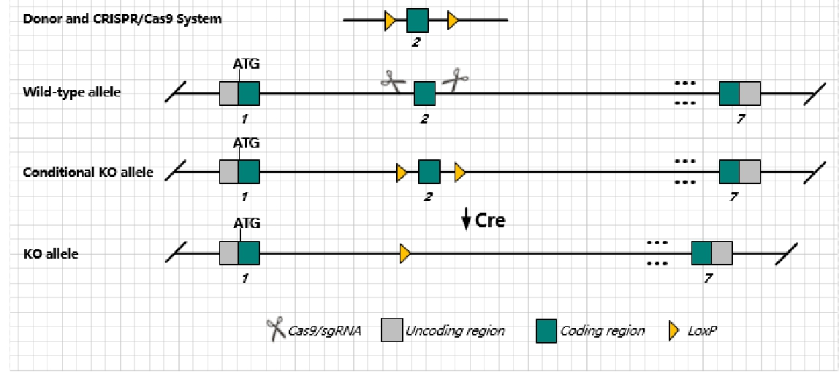
sgRNA | ACAAGAGTCTACTAGTCTAG AGG ACAAGAGTCTACTAGTCTAG AGG
Breeding method（♂x♀）
status | frozen
Genotyping | PCR+Sequence
Special feeding conditions | None
feed | SPF
maternal instinct | general
Strain description | Homozygous null mice display a delay in testis maturation but have normal spermatogenesis, sperm motility, and fertility.
Research areas | Developmental Biology
Reference

