Background Information

Strain Number | T005037
Strain Name | B6/JNju-Fbxo28^{em1Cflox}/Gpt
Used name | Fbx28; mKIAA0483; D1Ertd578e; 4833428J17Rik; 5730505P19Rik
Common name | Fbxo28
Complete time | 2019/2/20
Strain Type | Conditional Knock out Cas9
origin | Gempharmatech
Background | C57BL/6J
Algebra | F1
appearance | Black
Related geneS | Fbxo28
genotype | Fl/wt
Provided genotype | Heterozygote
Targeting Strategy | 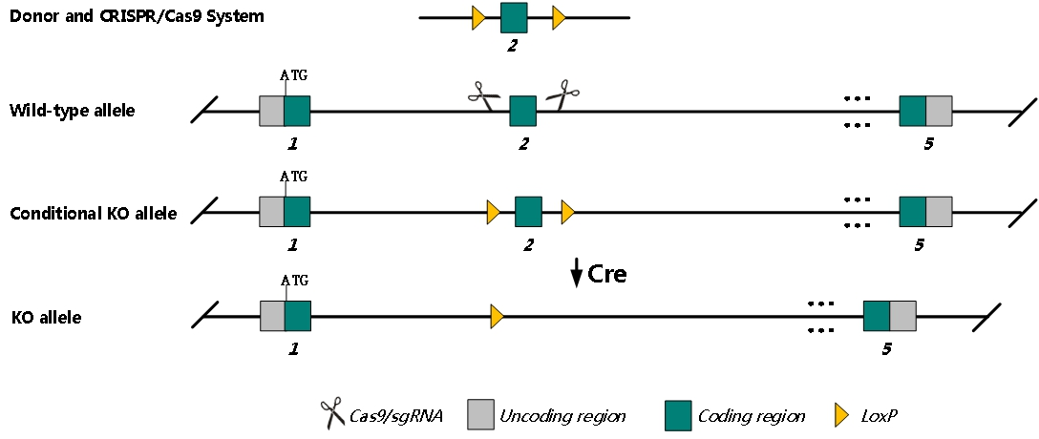
sgRNA | CTCTGCTAATTGCATGGCCG TGG GGCAGTGGTGACCCACATAA TGG
Breeding method（♂x♀）
status | frozen
Genotyping | PCR+Sequence
Special feeding conditions | None
feed | SPF
maternal instinct | general
Strain description | /
Research areas | /
Reference

