Background Information

Strain Number | T005166
Strain Name | B6/JNju-Fbxo39^{em1Cflox}/Gpt
Used name | 1700010H23Rik
Common name | Fbxo39
Complete time | 2019/2/27
Strain Type | Conditional Knock out Cas9
origin | Gempharmatech
Background | C57BL/6J
Algebra | F1
appearance | Black
Related geneS | Fbxo39
genotype | Fl/wt
Provided genotype | Heterozygote
Targeting Strategy | 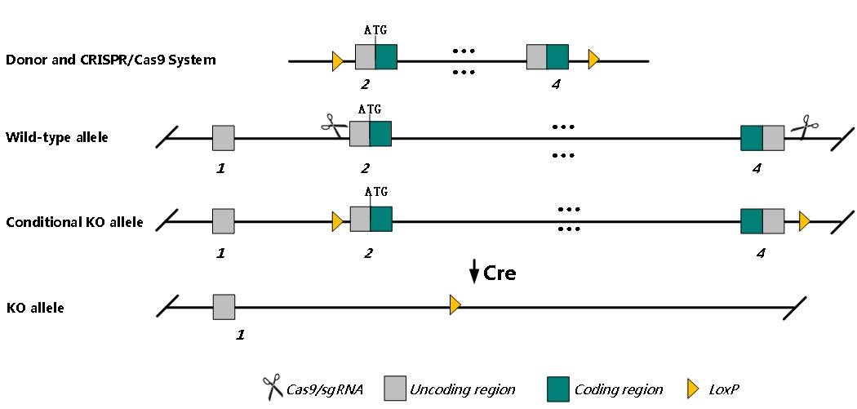
sgRNA | GGGGCATGCAACAAGATCCT GGG GGACCATTCCCACTCTTAGA AGG
Breeding method（♂x♀）
status | frozen
Genotyping | PCR+Sequence
Special feeding conditions | None
feed | SPF
maternal instinct | general
Strain description | /
Research areas | /
Reference

