Background Information

Strain Number | T005148
Strain Name | B6/JNju-Btrc^{em1Cflox}/Gpt
Used name | HOS; FWD1; Fbw1a; Slimb; b-TrCP; beta-TrCP; Beta-Trcp1; SCF b-TRCP; E3RSIkappaB; E3RS-IkappaB
Common name | Btrc
Complete time | 2019/2/27
Strain Type | Conditional Knock out Cas9
origin | Gempharmatech
Background | C57BL/6J
Algebra | F1
appearance | Black
Related geneS | Btrc
genotype | Fl/wt
Provided genotype | Heterozygote
Targeting Strategy | 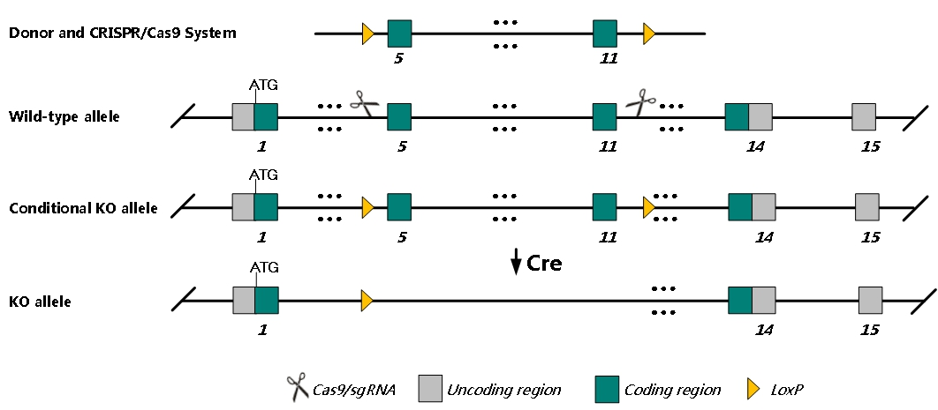
sgRNA | TCTGTGCGTCACCATAGGTT AGG CAGAGCTTCGTAGGAACGAC GGG
Breeding method（♂x♀）
status | frozen
Genotyping | PCR+Sequence
Special feeding conditions | None
feed | SPF
maternal instinct | general
Strain description | Embryonic fibroblasts from homozygotes show an increase in polyploidy and apoptosis and decreased cell proliferation. In a second allele, homozygous mutation results in reduced male fertility and abnormal male meiosis with oligozoospermia.
Research areas | Reproductive system
Reference

